Colleges of Education Libraries in Ghana: An Evaluative Study.
Christopher Kwame Filson¹ Baffour Ohene Agyekum^{2*}
- Assistant Librarian, University of Cape Coast, Ghana
- Assistant Librarian, Kumasi Polytechnic, Kumasi, Ghana
*kwaku73@yahoo.com
Abstract
The type of training that teachers undergo in Ghana is supposed to be characterized by the cultivation and sustaining of reading habits. This mission cannot be realized without proper libraries in the colleges of education. With the upgrading of colleges of Education in Ghana to the status of tertiary institution, one would expect that the image of libraries in colleges of education would be augmented. The study presents the results of an evaluative study of fourteen (14) colleges, representing 37.8% of the total number of colleges of education in Ghana. The article discusses amongst other factors such as budget, human resources, library collection services provided and physical facilities of the libraries being assessed. The study revealed that libraries in Ghanaian colleges of education are so poor, both quantitatively and qualitatively, that much remains to be done to enhance their status. The researchers hope that the recommendations given when fully implemented by the stakeholders will definitely raise the image of libraries in colleges of education in Ghana.
Keywords: Academic libraries, College libraries, Education, Colleges of Education.

INTRODUCTION
The quality of teacher education is of crucial value if education is to enhance development. This calls for the existence of educational facilities that will enhance proper teacher preparation and stimulation. One of the educational facilities which cannot be ignored is the library. The library is the heart of every institution, and therefore plays a very important role in the provision of professional teachers for the educational system of any nation. The library serves as resource centre where books and non-book materials are made accessible to all trainers and trainees of an institution. It plays a very important role in promoting the progress of knowledge (Aina, 2004).
In 2004, the government of Ghana in line with the recommendation of the Anamuah Mensah Education Review Committee empowered teacher training colleges to begin offering courses leading to the award of Diploma in Basic Education by the University of Cape Coast, Ghana. In furtherance of this, the Education Act 2008, Act 778 Clause 4 of Ghana categorically stated that “the colleges of Education were tertiary institution which should be established by an Act of parliament” Following the passage of the law, the Colleges of Education have now taken their rightful place within the ranks of tertiary institutions in Ghana. One is therefore expecting positive overhauls of all the facilities in the libraries of these colleges (PRINCOF, 2008).
In Ghana, colleges of education are meant to train teachers for the primary schools and junior high schools, mean while teacher preparation, monitoring and stimulation are factors that can enhance quality education capable of facilitating meaningful growth and enrichment of lives geared towards development, it is necessary that colleges of education should have functional libraries which will promote teaching, learning and research work so that teacher trainees could develop the habit of using the library and then probably pass on that habit to the children they will teach in the basic schools.
Currently libraries in the colleges of education in Ghana are considered to be academic libraries. This means that libraries in these institutions must be stocked in a way that they can support teaching, learning and research activities of the institutions. Hoare, Peter (1997) as quoted by Wikipedia indicated that an academic library is a library that is attached to an academic institution above secondary level serving the teaching and research needs of the students and staff. Also according to Wikipedia these libraries serve two complementary purposes: to support the curriculum, and to support the research of the faculty and the students. So the provision of adequate libraries should be a concern to stakeholders of any institution, in the same vein, creating conditions which will compare students and staff to make effective use of the resources of the library is also a challenge that needs to be addressed.

PROBLEM STATEMENT
Currently, there are thirty-eight (38) public colleges of education in Ghana and as usual these colleges are supposed to train teachers for the primary and junior high schools in the country. Although conscious efforts have been made by the Teacher and Education Division of the Ghana Education Service and the National Council for Accreditation Board to enhance the libraries in the colleges of education, do these libraries merit to be called academic libraries? And do they have the needed capacity to operate as academic libraries?
OBJECTIVES
The main objectives of this study are as follows;
1. To find out if these libraries have adequate funding
2. To find out how relevant library materials in the selected colleges of education are to the teaching, learning and research activities of the institutions.
3. To find out conditions of colleges of education libraries in terms of adequate facilities.
4. To find out the calibre of staff in charge of the libraries.
5. To make recommendations that will augment the current state of these libraries.
BRIEF HISTORY OF TEACHER TRAINING EDUCATION IN GHANA
Training of Teachers in the Gold Coast (Ghana) began in the 1840s when the Basel Mission, anxious to train African Assistants for their schools, established a training school for catechists at Akropong (Akwapim) in 1848 and followed it up with others later. Also an attempt was made by the Wesleyans to train teachers in Cape Coast, Anomabu and Accra. The church members were urged to choose the most promising boys to be trained as teachers since that was the practice in England (Graham, 1976).
Ever since 1848, elementary school teachers in Ghana have been trained in second-level institutions for instance, the pupil teacher system. Initially teachers were trained for two years, but the two-year course was replaced with four-year courses, along the two year post secondary programme. Later, a four-year course was introduced which was intended to extend and complete the general education of intending teachers who had received their education in elementary schools only. Emphasis in the first two years was on a general education which in content was very similar to that in courses in academic secondary schools (Antwi, 1992)
Following the implementation of the Accelerated Development Plan for Education in 1951, it was decided to recruit a large number of pupil teacher-students with a weak academic background, who consequently, had to be given six week intensive courses to prepare them for teaching in the primary schools. In 1953, 10 Pupil Teacher Centers were established for this purpose and curriculum of the centers emphasized English, Arithmetic and Pedagogy (Antwi, 1992).
In order to meet the specialist staffing needs of middle schools in 1965, two-year specialist teacher training courses for certificate teachers in English, Geography, History, Mathematics, and so forth were offered in nine teacher training colleges. These specialist course moved together to form the nucleus of the Advanced Teacher Training College, Winneba, Ghana in 1966 (Datta, 1984). In the same year it was realized that sixty-seven (67%) of primary school teachers were untrained, the government therefore opened thirty five (35) new teacher training colleges in addition to the existing 45 to bring to 80, but by 1980/81 the Teacher Training Consolidation Scheme, also known as the Contraction policy, resulted in the closing down of some of the teacher training colleges which stood at 80 to 38.
With the implementation of the new educational reform in 1987 in Ghana, the Universities Rationalization Committee (URC) saw the need for Regional Colleges of Applied Arts, Science and Technology to be established but this dream was not realized (Pecku, 1997).
PRINCOF (2008) pointed out that between July and August 1997, a Teacher Education Conference was convened at Winneba, Ghana, to discuss and suggest a policy framework to guide the development of teacher education in Ghana in the next few years. The issues which came out included the following:
- Basic teacher qualification to be earned from the upgraded teacher training colleges should be a Diploma.
- Training colleges should be part of the Regional Colleges of Applied Arts and Science Technology
- Teacher training should be school- based.
- The new structure of training should be IN-IN-OUT.
- There should be internship period before certification
- Diploma holders should upgrade to B.Ed Degree through Distance Education.
In 2007, the government of Ghana decided to come out with a policy which makes all pre-university teacher training colleges tertiary institutions, in view of this the National Council for Tertiary Education ( NCTE) was to play a major role in the implementation of the policy. The NCTE together with the National Accreditation Board was to ensure that certain facilities are available in the colleges of which the library was one of them. In March, 2012, Act 847 of the Parliament of the Republic of Ghana was passed making Colleges of Education take their rightful position as tertiary institutions in the country. This means that libraries in these colleges of Education are now academic libraries.
LITERATURE REVIEW
Nature of School and College Libraries in Ghana.
Studies conducted by Osei-Bonsu, M (1990), Alemna,A.A(1990), Rosenberg, D (1998) have shown school libraries in Ghana are very poor, both qualitatively and quantitatively due to myriad of problems they face. One of the major reasons for this predicament according to Rosenberg (1998) and report from the President’s committee on review of educational reforms in Ghana (2000) is the poor of impact of the school and colleges department (SCD) of the Ghana Library Board now Ghana Library Authority. SDC was established in 1972 and was mandated to care for school and college libraries in Ghana .Reasons given for the overall lack of impact of SCD are: official interest in libraries has been 'cool and casual, rather than active and sustained' (Alemna 1996). This lack of commitment by government and lack of interest by school principals and heads is seen as the main reason why standards (neither those laid down in the 1972 Manual for School Libraries in Ghana, nor those proposed by Alemna in (1993) have not been adopted, legislation has not been introduced, and monies allocated to libraries have often been diverted for other purposes among others Alemna (1998).
According to the Report of the President’s Committee on Review of Educational Reforms (2002), all libraries in Ghana face common problems, which include the following:
- Poor and in some cases, lack of accommodation;
- Lack of libraries in some schools;
- Inadequate funding;
- Poor service conditions for staff, especially in the public libraries;
- Poor facilities for Information and Communication Technology (ICT) application;
- Outdated reading materials; andewsletter Title Page 10
- The Ghana Inter-Library Lending and Document Delivery Network (GILLDNET) for the universities is ineffective in providing the required services.
Earlier studies conducted by Enstua-Mensah and Ahwoi (2009), Alemna (2000) and Agyekum and Filson (2012) confirm the above state of school libraries in Ghana.

METHODOLOGY
There are thirty- eight (38) public colleges of education in Ghana, but for the purposes of this study, the researchers decided to use sixteen (14) of the colleges representing 37% of the number of colleges. The colleges under studied were in the Central, Eastern and Ashanti regions of Ghana. A questionnaire was designed to gather information on the state of the colleges of education libraries. The questionnaire was divided into eight (8) sections; the first and second sections contain questions relating to the bio data and the quality of staff working in the library. The third section dealt with the committee and the department responsible for the management of the library. The sections four and five looked at the library stock and budget of the library, the sections six and seventh handled questions on access to the information and the accommodation. The last section contained questions relating to the level of patronage of the library.
There was an excellent response to the questionnaire. The entire questionnaires were returned though late and they were analyzed and presented in statistical form, the information obtained was then interpreted to produce data for the paper. For the purposes of simplicity, the discussions were based on the various sections of the questionnaire at their offices.

ANALYSIS AND DICUSSION OF DATA
Table 4.1 Frequency Distribution on Demographic Characteristics of Respondents
Variable | Frequency | Percentages | Total
Sex |  |  | 14
Male | 9 | 64.3
Female | 5 | 35.7
Age |  |  | 14
26-30 | 1 | 7.1
31-35 | 5 | 35.7
36-40 | 1 | 7.1
41-45 | 6 | 42.9
51-55 | 1 | 7.1
Academic qualification |  |  | 14
MSLC | 2 | 14.3
SSSCE | 4 | 28.6
1st Degree | 6 | 42.9
2nd Degree | 1 | 7.1
GCE/O'Level | 1 | 7.1
Working Staff |  |  | 14
One Staff | 3 | 21.4
Two Staff | 6 | 42.9
Three Staff | 3 | 21.4
More than Four Staff | 2 | 14.3
Professional Staff |  |  | 14
None | 8 | 57.1
One professional | 6 | 42.9
Para-Professional |  |  | 14
None | 12 | 85.7
One Para- professional | 2 | 14.3
Non-Professional
None
One non-professional | 5 | 35.7
Two non-professionals | 4 | 28.6
More than Two non- Professionals | 5 | 35.7
In-Service Training for Non-Professional Staff |  |  | 14
None | 6 | 42.9
One Non-professional | 6 | 42.9
Two Non-Professionals | 2 | 14.3
Head of the library |  |  | 14
Principal | 7 | 50
Languages H.O.D | 1 | 7.1
Authorities | 6 | 42.9
Library Department |  |  | 14
Language Department | 8 | 57.1
Academic affairs | 1 | 7.1
Missing | 5 | 35.7
Library Committee |  |  | 14
Yes | 6 | 42.9
No | 8 | 57.1
Role of the Committee |  |  | 14
Advisory | 5 | 35.7
Policy making | 1 | 7.1
Missing | 8 | 57.1
Library Represented |  |  | 14
Yes | 3 | 21.4
No | 11 | 78.6
Source; Field work. November, 2013
In Table 4.1 is a frequency distribution the demographic characteristic of the respondents which revealed that about 64.3% of the librarians are males, whiles 35.7% were also females. Also for the age groups, it was found that at 42.9% and 35.7% of the librarians were within the age group of 41-45 and 31-35 respectively. Furthermore, 42.9%, 28.6% and 14.3% of the librarians were holding 1St Degree, Senior Secondary School Certificate of Education (SSSCE) and Middle School Leaving certificate (MSLC) certificate respectively. Meanwhile only 7.1% were holding Second Degree and GCE//O' Level. Moreover, on library staff working in the libraries, it can be observed that the majority of the colleges have only two staff, which represents about 42.9% of the total response rate whiles 21.4%, 21.4% and 14.3% of the colleges had three staff, One staff and four staff respectively. Also about 57.1% of the total staff were not professionals whiles only 42.9% of the staff were professional. It was also revealed that majority of the library staff were not Para-professional, which constitute about 85.7% and only 14.3% of the librarians were Para-professional. It can also be noted that all the colleges indicated that most of their staff were non-professionals. Also about 42.9% of non-professionals library staff were not trained in librarianship, whiles 42.9% and 14.3%of non-professionals library staff were given in service training in librarianship for “Once” and “Twice” respectively. Finally, about 50.0% of the libraries are being headed by Principals and 42.9% were also headed by college authorities. It was also observed that, the majority of the colleges’ libraries were under the English language departments and this shows about 57.1% of the total response rate.
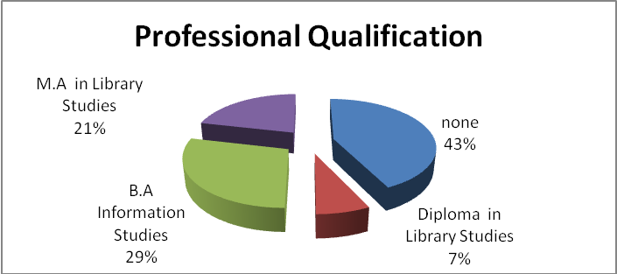
Figure 4.1Pie Chart on the Professional Qualification
Source; Field work. November, 2013.

In Figure 4.1 above is a professional qualification of the respondents and it was shown that the majority of the librarians were not having any professional qualification. This constitutes about 42.9% of the total response rate. Also about only 28.6%, 21.4% and 7.1% of the respondents has a Certificate in Library Studies, M.A in Library Studies and Diploma in Library Studies respectively.
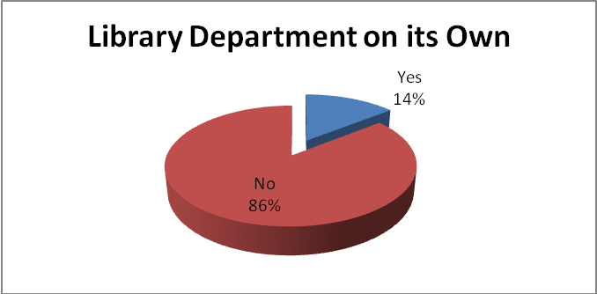
Figure 4.2 Pie Chart of the Library Department on its Own
Source; Field work. November, 2013.

From the Figure 4.2 above, is a pie chart on the library department, it was found that about 85.7% of the library departments of the various colleges were not on its own. Also about 14.0% of the colleges have their own library department.
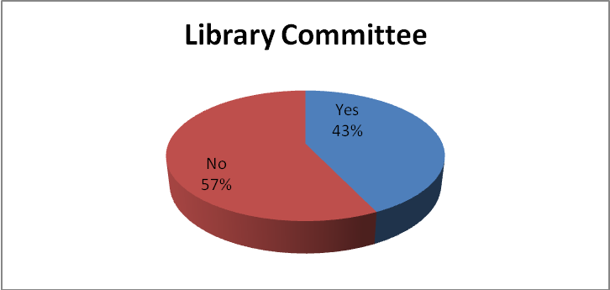
Figure 4.3 Pie Chart on the Library Committee
Source; Field work. November, 2013.

In Figure 4.3 it was revealed that the majority of the colleges do not have library committee. This constitutes about 57.0% of the total response rate. Meanwhile, only 43.0% colleges have library committee.
Table 4.2 Frequency Distribution of Library Materials
Variable | Frequency | Percentages | Total
How are library materials acquired |  |  | 14
As donation | 1 | 7.1
By purchasing | 1 | 7.1
From the government | 12 | 85.7
Collection Development Policy |  |  | 14
Yes | 1 | 7.1
No | 13 | 92.9
Does the library receive inputs on selection from? |  |  | 14
Faculty | 4 | 28.6
Department | 6 | 42.9
Individual lecturers | 1 | 7.1
Students | 1 | 7.1
Library staff | 2 | 14.3
Total stock of the library |  |  | 14
Less than 1000 | 3 | 21.4
1000-10000 | 9 | 64.3
10000+ | 2 | 14.3
The percentage of the stock published after 2008? |  |  | 14
0-20 | 5 | 35.7
21-40 | 6 | 42.9
40+ | 3 | 21.4
Does the library have a material retention policy |  |  | 14
Yes | 8 | 57.1
No | 6 | 42.9
Has the library online access to bibliographic database |  |  | 14
Yes | 0 | 0
No | 14 | 100
Has the library access to online full text document delivery |  |  | 14
Yes | 0 | 0
No | 14 | 100
Does the library have sufficient funding to pay for full text documents when necessary |  |  | 14
Yes | 1 | 7.1
No | 13 | 92.9

Source; Field work November, 2013.
From Table 4.2 above is a distribution of Library Materials. There is statistical evidence that library materials are mainly acquired or provided by the Government, which shows about 85.7% of the response rate. Whiles only 7.1% and 7.1% of the library materials are also acquired by donation and purchases. Moreover, it was revealed that about 92.9% of the college’s libraries are not having a collection development policy. Also the library received its input on the selection from the departments and faculties. This shows a value of 42.9% and 28.6% respectively. Furthermore, it was also observed that about 64.3% of the college’s libraries have a total stock of books between 1000 to 10,000 books and only 21,45 and 14.3% were also having a total stock of books less than 1000 and above 10,000 respectively. In addition, among the total stock for the colleges, only 42.9% of the colleges have 21-40 stocks of books published after 2008. Meanwhile, 35.7% of the colleges have less than 20 stocks published after 2008. Finally, it was found out that, about 100% of the college’s libraries have no online access to bibliographic database, and that, about 100% of the colleges’ libraries’ do not have access to online full text document delivery. Lastly, about 92.9% of the colleges’ libraries have insufficient funds to pay full text document when it’s necessary to undertake.
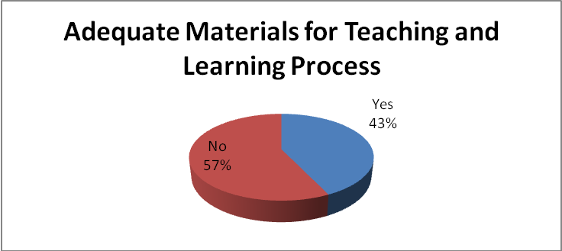
Figure 4.4 Pie Chart on the Adequate for Teaching and Learning Process
Source; Field work. November, 2013.
From Figure 4.4 above is a pie chart on library material and there is statistical evidence that, about 57.0% of the college’s libraries have inadequate library materials for teaching and learning. On the other hand, only 43.0% of the libraries were having adequate teaching and learning material.

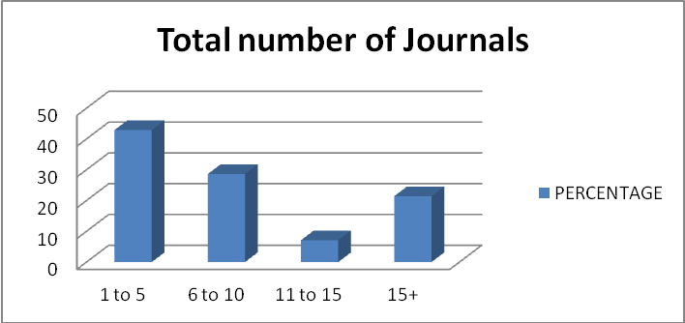
Figure 4.5 Bar Chart on the Total Number of Current Journals
Source; Field work. November, 2013.

In Figure 4.5 above it was shown that about 42.9% of the colleges received a total of 1-5 current journals. Also 28.6%, 21.4% and 7.1% of the college received a stack of 6-10, more than 15 and 11-15 current journals respectively.
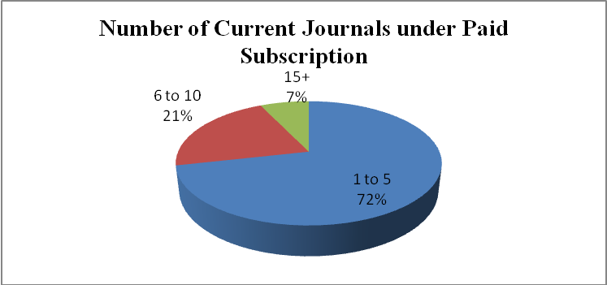
Figure 4.6 Pie Chart on Number of Current Journals under Paid Subscription
Source; Field work. November, 2013.
In Figure 4.6 above, it was revealed that, about 72.0% of 1 to 5 current journals are under paid sudscription. Whiles only 21.0% of 6 to 10 and 7% thus 15+ current journals are under paid subscription.

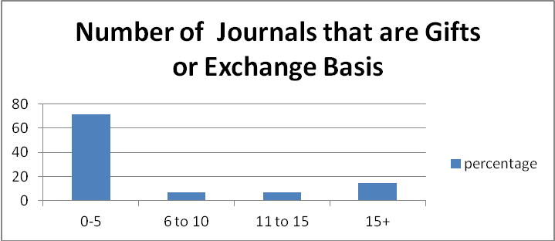
Figure 4.7 Bar Chart on the number of journals that are gifts or exchange basis
Source; Field work. November, 2013.

In Figure 4.7, it can be observed that about 71.0% of the library materials of less than 5 are acquired by gift. Also about 14.3%, 7.1%, and 7.1% of the material from 6 to10, 11 to 15 and more 15 respectively are also acquired by gift.

Table 4.3 Frequency Distribution on Library Budget and Library Access and Services
Variable | Frequency | Percentages | Total
Sources of Funds for Library |  |  | 14
Discuss with the Principal | 3 | 21.4
Government | 6 | 42.9
Authorities | 3 | 21.4
Dues for students | 2 | 14.3
ACCESS &SERVICES |  |  | 14
Collection Catalogued
Yes | 9 | 64.3
No | 5 | 35.7
Method of Catalogued
Manual | 12 | 85.7 | 14
Automated | 2 | 14.3
Collection Classified
Yes | 9 | 64.3 | 14
No | 5 | 35.7
Classification System
Library of Congress classification scheme | 8 | 57.1 | 14
Dewey | 3 | 21.4
None | 3 | 21.4
Library Orientation
Yes | 9 | 64.3 | 14
No | 5 | 35.7
Computers at the Library
None | 3 | 21.4 | 14
1 to 3 | 9 | 64.3
4 to 6 | 1 | 7.1
6+ | 1 | 7.1
Source; Field work. November, 2013.

In the Table 4.3 above, it was observed that the libraries source of funds comes from the Government and college authorities; this contributes about 42.9% and 21.4% respectively. Moreover, there was evidence that, 64.3% of the libraries’ collection were catalogued, whiles only 35.7% were not catalogued. Within the catalogued library collections, about 85.7% were manual. Also, about 64.3% of the libraries collections catalogued were classified and only 35.7% were not classified. Finally, within collection classification, about 57.1% were classified under Library of Congress classification scheme and only 21.4% were under Dewey Classification. Again 64.3% of colleges’ libraries organize an orientation session for its clients.
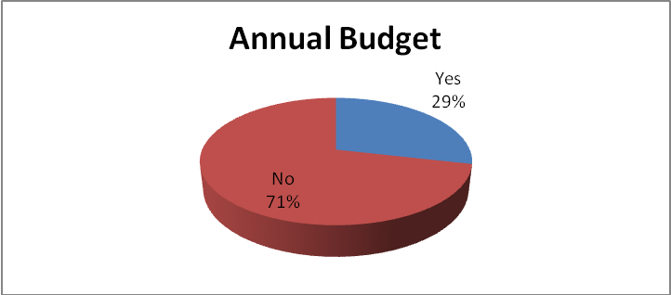
Figure 4.8 Pie Chart on Library Annual Budget
Source Field Work. November, 2013.

In the Figure 4.8 above, it was found that about 71.4% of the colleges’ libraries do not have an annual budget, whiles only 28.6% of the libraries were having their annual budget.
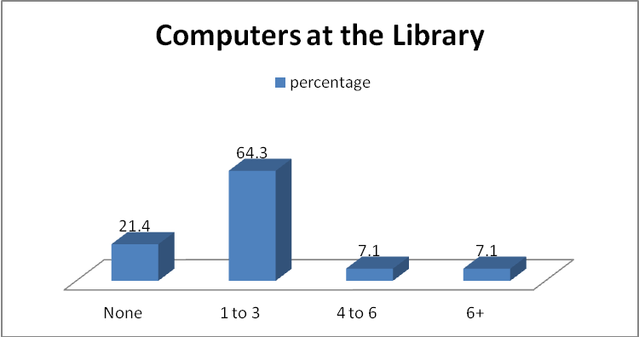
Figure 4.9 Bar Chart on the Computer at the Library
Source: Field work. November, 2013.
Finally, In Figure 4.9 above it was revealed the majority of the libraries have 1 to 3 computers in their offices. This shows about 64.3% of the total response rate. Whiles, 21.4% of the libraries do not have a computer at their offices.
Table 4.4 Frequency Distribution on Library Building facilities and Library Patronage
Variable | Frequency | Percentages | Total
BUILDING
Housed |  |  | 14
Centralized in one building | 13 | 92.9
Dispersed at several locations | 1 | 7.1
Total Area of the Library |  |  | 14
Don’t know | 5 | 35.7
20 by 40 feet | 1 | 7.1
25 by 40 feet | 1 | 7.1
40 by 120 feet | 1 | 7.1
40 by 90 feet | 2 | 14.3
40 by 150 feet | 3 | 21.4
32 by 32 feet | 1 | 7.1
Seats Available |  |  | 14
1 to 50 | 8 | 57.1
51 to100 | 4 | 28.6
101 to 150 | 1 | 7.1
150+ | 1 | 7.1
Librarian Office |  |  | 14
Yes | 8 | 57.1
No | 6 | 42.9
Separate Room for Technical Activities |  |  | 14
Yes | 5 | 35.7
No | 9 | 64.3
Building User Friendly |  |  | 14
Yes | 7 | 50
No | 7 | 50
Library Hall Ventilated |  |  | 14
Yes | 11 | 78.6
No | 3 | 21.4
Ventilation Facilities |  |  | 14
Fan | 12 | 85.7
Air condition | 2 | 14.3
PATRONAGE OF THE LIBRARY
Total Students Population |  |  | 14
1-300 | 1 | 7.1
301-600 | 4 | 28.6
601-900 | 9 | 64.3
900+
Total Students who visit the Library in a Day |  |  | 14
1 to 30 | 6 | 42.9
31- to 60 | 3 | 21.4
61 to 90 | 2 | 14.3
90+ | 3 | 21.4
Total Students who visit the Library in a Week |  |  | 14
1-100 | 5 | 35.7
101-200 | 3 | 21.4
201-300 | 2 | 14.3
301-400 | 2 | 14.3
401-500 | 1 | 7.1
500+ | 1 | 7.1
Total Tutors/Lecturers in the College |  |  | 14
1 to 50 | 1 | 7.1
6 to 10 | 7 | 50
11 to 15 | 5 | 35.7
15+ | 1 | 7.1
Total Tutors/ lecturers who visit the Library in a Week |  |  | 14
1 to 20 | 5 | 35.7
21 to 40 | 7 | 50
41 to 60 | 1 | 7.1
60+ | 1 | 7.1

Table 4.4 above, is a distribution on library building facilities and library patronage. It was revealed that, about 92.1% of the library and information facilities are centralized in one building and 7.1% of the library and information are dispersed at several locations. Also about 57.1% of the libraries have a seat between1-50, whiles only 28.6% of the library had seats between 51 to100. It was shown that, about 57.1% of the librarians have their own office. On the other hand, about only 42.9% were not having their own office. Also, it was found out that, 64.3% of the librarians/ do not have a separate room for carrying out technical process. We can also observe that, about 78.6% of the library halls are well ventilated and about 85.7% of them were ventilated by “Fan.”. Furthermore, it was also revealed that 28.6%, and 64.3% of the colleges have students between 601and 900, 301and 600 respectively. It was also shown that, about 42.9% of the students between 1 -30 visit the library for a day. Meanwhile, only 21.4% and 21.4% of the students between 31-60 and 90+ respectively visit the library in a day. The majority of the students who visit the library in a week are between 1-100 students. This contributes about 35.7% of the total response rate. On the other hand, only 21.4%, 14.3% and 14.3% of the students who visit the library in a week are between 101-200, 201-300 and 301-400 respectively. In addition, about 50.0% and 35.7% of lecturers in the colleges were between 6-10 and 11-15 respectively. Finally, there was evidence that about 50.0% of lecturers between 21- 40 visit the library in a week. Meanwhile only 35.7%, 7.1% and 7.1% of lecturers between 1-20, 41-60 and More than 60 respectively visit the library in a week.

SUMMARY OF THE FINDINGS
Professional qualification of Staff
According to The Association of College and Research Libraries (2011) libraries should provide sufficient number and quality of personnel to ensure excellence and to function successfully in an environment of continuous change. Study revealed that the majority of the staff were non-professionals. One would have thought that with this problem, in-service training would be organized for the non professionals; however the study also indicated that only few colleges allowed or organize in- service training for their staff.
The above situation is detrimental to an academic library because the effective performance of a library depends largely on the library’s staff Personnel in academic libraries require diversified backgrounds in order to meet the teaching and learning needs of users, but the study pointed out that most of the staff have as low as elementary certificate. Librarians should have appropriate educational backgrounds in library and information science as well as in other disciplines to advance the library’s involvement in academic programmes.
Management of the libraries
Libraries engage in continuous planning and assessment to inform resource allocation and to meet their mission effectively and efficiently (ACRL 2011). For reason an academic library should have a sustentative head so far as administration and proper management of the library is concerned, but the majority of the respondents did indicate that their libraries are headed directly by their principals. Principals who have no idea in librarianship may decide to ignore the library entirely. The study also pointed out that some heads of institutions turn to appoint the Head of the Language Department to oversee the library. The study proved the misconception that the library should be headed by linguists, the above problem could be minimized if there were library committees to serve as the advisory boards for the library however they study pointed out the majority of the colleges have no library committees.
Collection development procedures
In an academic library it is important to develop a collection of a high standard because that is the way of attracting prestigious academic and researchers to an institution. According to Adekanmbi (2007) libraries should have collection development policy because it provides justification for the inclusion of each material in the library, but the study revealed that most of the colleges do not have collection development policy.
Also most of the colleges depended entirely on the government for library materials; however the study indicated that there is a problem with government funding. This problem has derailed the smooth stocking of the libraries with the requisite materials. The development of the library collection should be adequately funded to maintain growth in existing areas and ensure that new areas are taken care of. The development of library collections should be a joint effort between staff of the library and the faculty to ensure procurement of relevant materials which according to the study was adhered to by some of the colleges. It can also be deduced that the materials in the libraries are irrelevant and inadequate to the teaching and learning activities of the institutions.
Electronic support and other services provided
The main purpose of an academic library is to support teaching, learning and research activities, in order to realize this there is the need for the academic library to make provision for electronic and non electronic materials. From the data analysed it can be seen that all the colleges of education studied has no electronic support unit even though some of them have computers. This means that students are limited to the use of print materials only, but it must be noted that Online electronic sources, both bibliographic and full text, now form a significant part of the information network needed by academic institutions.

Funding of the libraries
To sustain the library’s growth and development through periodic stocking, renovation maintenance, replacement, repairs, and for investment in new and improved means of information access and delivery the library needs to be adequately funded (Philippine Association of Academic and Research Libraries (2000), but the study revealed that spending money on the libraries was a problem hence the inability of the libraries to function properly. Again it was revealed that most libraries have no budget on their own but depended heavily on funds from the Government which is woefully inadequate. However preliminary interview conducted by the researchers revealed that students pay library fee, this money we think, could be used to procure few materials for the library.
Patronage of the libraries
The study pointed out that teaching staff and students patronise the library even though they claim that most of the materials were irrelevant to the teaching, learning and research activities. This could be due to the fact that teacher training education in Ghana is such that student trainees are given series of assignments to be done so students use the libraries as reading rooms since the staff common rooms and student dormitories are not suitable for private studies.
Library Building facility of the colleges
A preliminary investigation conducted at the National Quarters of the Teacher Education Division of the Ghana Education Service revealed that the total intake of students is on the average of two hundred and thirty (230) per class this means that there is an average of 690 students in each college, but according to the study, most college libraries operate in buildings of 40 ft by150 ft in size. Such a building cannot seat twenty percent (20%) of the total number of students and staff. It was also noted that most of the schools do not have a section for technical service section as well as librarian’s office. This means that some of the library buildings were not purposely built to serve as libraries.

RECOMMENDATIONS
- The National Council for Tertiary Education of Ghana should ensure that libraries in colleges of education are well stocked with books.
- The National Accreditation Board of Ghana should make its report on libraries in the colleges of education known to the stakeholders of education especially the government and parents.
- Urgent steps should be taken to make libraries in colleges of education hybrid libraries so that information can be accessed in print and non-print format.
- Government should ensure that libraries in colleges of education are provided with the needed facilities.
- Since colleges of education are to train teachers for the basic schools in Ghana, the researchers would suggest that library studies should be taught at the colleges of education.
- Librarians in the colleges of education should be ranked like those in the public universities; this means that Professionals, para-professionals librarians and other professionals should be employed at the colleges of education.
- Institutions should ensure that their library staffs are fully involved in making decisions which affect the management of information.
- Librarians, on the other hand, should not allow their professional identity to isolate them from other aspects of institutional management
- Heads of Colleges of Education need to be sensitised on the role of the academic library in the teaching, learning and research activities of the teacher training education in Ghana.
- To achieve organisational and managerial integration between library and other services there is the need for the library staff to work with the teaching staff of the institution in terms of collection development.
- Teaching staff should integrate the usage of the library into the teaching, learning and research activities of the institution.

CONCLUSIONS
The inability of the Schools and Colleges Department of the Ghana Library Board (Now Ghana Library Authority) to administer its role of ensuring the existence of functional libraries in the basic schools, secondary schools and teacher training colleges has negatively affected college libraries we have in Ghana.
In this era, where information is kept in print and electronic form, academic or college libraries should be hybrid libraries, but it can be concluded that all the colleges of education libraries studied operate with about ninety-nine percentage (99%) print materials. This situation can render these libraries underutilized.
Finally, lack of professional librarians in these colleges coupled with the inability of Principals of Teacher Training Colleges of Ghana (PRINCOF) to ensure that college libraries are functional are some of the contributing factors to the poor nature of libraries in colleges of education. Because of these problems student trainees and staff visit the libraries not because of the materials, but to use the library as study room. This means that drastic measures should be adopted in order to salvage the image of libraries in Colleges of Education.
References
Adekanmbi. A.R. (2007). Availability and use of collection development policy of colleges of education
libraries, Botswana. African Journal of Library, Archives and information Science, 17 (1) 46.
Agyekum, B.O & Filson, C.K. (2012). The Challenges of School Libraries After the Implementation of the New Educational Reforms in Ghana. Library Philosophy and Practice (e-journal). Paper 932. http://digitalcommons.unl.edu/libphilprac/932. Accessed (July 23, 2013)
Alemna, A. A. (1990). The school library in Ghanaian education: an analysis of issues and problems. Nigerian Library and Information Science Review, 8 (2): 1-9.
Alemna, A. A. (1996) The future of school libraries in Ghana. 8p. (Unpublished paper)
Alemna A.A. (1998) School Libraries in Ghana: A State of the Art Report. http://www.iasl-online.org/pubs/slw/slwjuly98.html. Accessed (July 19 2013)
Alemna, A. A. (2000). Libraries Information and Society, Ghana: University press, Accra, p 9.
Antwi, M.K. (1992) Education, Society and Development in Ghana. London: Macmillan Publishers Limited, pp 112-118
Association of College and Research Libraries (2011) The Standards for Libraries in Higher Education: http://www.ala.org/acrl/standards/standardslibraries. Accessed (July 15 2013)

Philippine Association of Academic and Research Libraries (PAARL 2001) Standards for Academic Libraries for 2000: en.wikipilipinas.org/index.php?title=PAARL‎ Accessed (July 18 2013)

Datta, A (1984). Education and Society: Sociology of Arican Education. London: Macmillan, pp 115-120
Entsua-Mensah, C., & Ahwoi, E. (2009). Functional Libraries for Purposeful Education in Ghana: The Need for a School Library Policy. http://ir.ucc.edu.gh/dspace/handle/123456789/1001. Accessed (July 19 2013)
Ghana, (2002). Meeting the Challenges of Education in the twenty first century: Report of the President’s Committee on Review of the Educational Reforms in Ghana:
Executive summary, Accra: Adwinsa. pp 209-213.
Graham, C.K. (1976). The history of Education in Ghana. Tema: Ghana Publishing Corporation, p 29
Ghanaian Daily Grahpic ( 6th September, 2012 ) Communiqué issued by the National Conference of Principals of Colleges of Education (PRINCOF ) at the end of her 54th Annual Conference and workshop held at the Anita Hotel, Ejisu, Ghana, from the 26th 31st of August, 2012
Hoare, Peter (1997) Academic libraries in international Encyclopedia of Information and library Science, New York. Routledge P.2
PRINCOF (2008). Developments in Basic Teacher Education in Ghana, Kumasi: Greenland’s Concept, pp 149-154
Rosenberg, D (1998). School Library Services: Ghana and Tanzarnia. In Getting Books To Pupils In Africa: Education Research Paper, No 26. Edited by Dina Rosenberg.
http://www.cd3wd.com/cd3wd_40/HDLHTML/EDUCRES/DEP26E/EN/BEGIN.HTM#CONTENTS. Accessed (June, 19 2013).
Teacher Education Division, Brochure, (2009). Ghana Education Service
Osei-Bonsu, M. (1990) Secondary school libraries in Ghana: an evaluative study. International Review of Children's Literature and Libraries, 5 (2): 87-105

